**DATA STRUCTURES LAB EXPERIMENTS**

Sanskruti Samant

USN: 2GI17EC113

DIV: B

**Experiment Number:** 6c

**Title:** Implementation of Search operation in Binary tree Using C++.

**Problem Statement:**

Write a C++ program to implement the search operation in Binary tree.

**Algorithm:**

* Whenever an element is to be searched, start searching from the root node
* Then if the data is less than the key value, search for the element in the left subtree.
* Otherwise, search for the element in the right subtree.
* Follow the same steps for each node.

**Code:**

#include<iostream>

using namespace std;

struct node {

int d;

node *left;

node *right;

};

node* CreateNode(int d) {

node *newnode = new node;

newnode->d = d;

newnode->left = NULL;

newnode->right = NULL;

return newnode;

}

node* InsertIntoTree(node* root, int d) {

node *temp = CreateNode(d);

node *t = new node;

t = root;

if(root == NULL)

root = temp;

else {

while(t != NULL) {

if(t->d < d) {

if(t->right == NULL) {

t->right = temp;

break;

}

t = t->right;

} else if(t->d > d) {

if(t->left == NULL) {

t->left = temp;

break;

}

t = t->left;

}

}

}

return root;

}

void Search(node *root, int d) {

int depth = 0;

node *temp = new node;

temp = root;

while(temp != NULL) {

depth++;

if(temp->d == d) {

cout<<"\nitem found at depth: "<<depth;

return;

} else if(temp->d > d)

temp = temp->left;

else

temp = temp->right;

}

cout<<"\n item not found";

return;

}

int main() {

char ch;

int n, i, a[10] = {93, 53, 45, 2, 7, 67, 32, 26, 71, 76};

node *root = new node;

root = NULL;

for (i = 0; i < 10; i++)

root = InsertIntoTree(root, a[i]);

up:

cout<<"\nEnter the Element to be searched: ";

cin>>n;

Search(root, n);

cout<<"\n\n\tDo you want to search more...enter choice(y/n)?";

cin>>ch;

if(ch == 'y' || ch == 'Y')

goto up;

return 0;

}

**Output:**

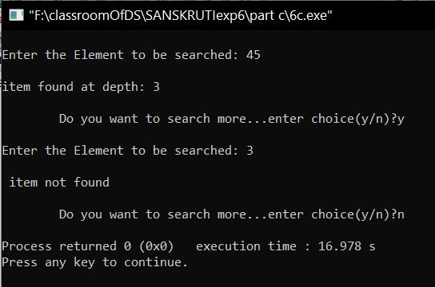

**Analysis / limitations:**

* Slower insertion/deletion of elements.
* Not a great choice for linear trees (degenerate tree - more or less a sorted linked list)